[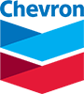](https://www.chevron.com/)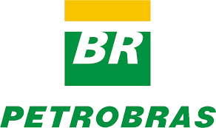 BASF

[](https://www.kindermorgan.com/)

**Formosa Plastics Corp.**

